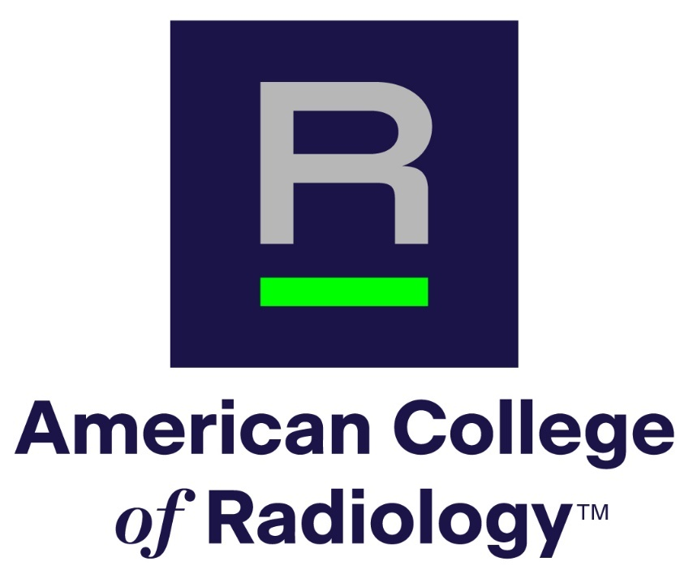

**APPLICATION FORM**

**AMERICAN COLLEGE OF RADIOLOGY**

**Richard L. Morin, PhD Fellowship in  
Medical Physics**

1. General Information

* Name:
* Institution and/or residency program:
* E-mail:
* City & state:
* Phone:
* Subspecialty (if applicable):
* Name of Program Director:
* Department Chair (if applicable):
* Current year in residency:
* Expected year of residency completion:

1. Please identify two current top areas of interest

* Area 1:
* Area 2:

1. Please choose at least one accreditation modality or program of interest:

* Program 1:
* Program 2 if applicable:

1. Personal statement describing how this fellowship relates to your career goals. Please do not exceed **500** words.
2. What prior experiences (activities, courses, and jobs) have best prepared you for this fellowship? Please do not exceed **300** words.
3. Why are you applying for this fellowship and what do you hope to gain from it? Please do not exceed **300** words.
4. Please save and submit this application as a pdf through the submission page
5. Please include a copy of your CV, as indicated on the submission page
6. Please have a professional portrait available in case of selection for the award
7. Please have your 2 Reference Letters submitted through the upload portal linked on the [Morin Fellowship landing page](https://www.acr.org/Member-Resources/rfs/fellowships/Morin-Fellowship)

Questions? Please email Dustin Gress, ACR Senior Advisor for Medical Physics:

[dgress@acr.org](mailto:dgress@acr.org)